**2. Economic Performance Analysis**

USE world_bank_data;

-- Retrieve all data from economic_indicators table

SELECT *

FROM economic_indicators

LIMIT 10;

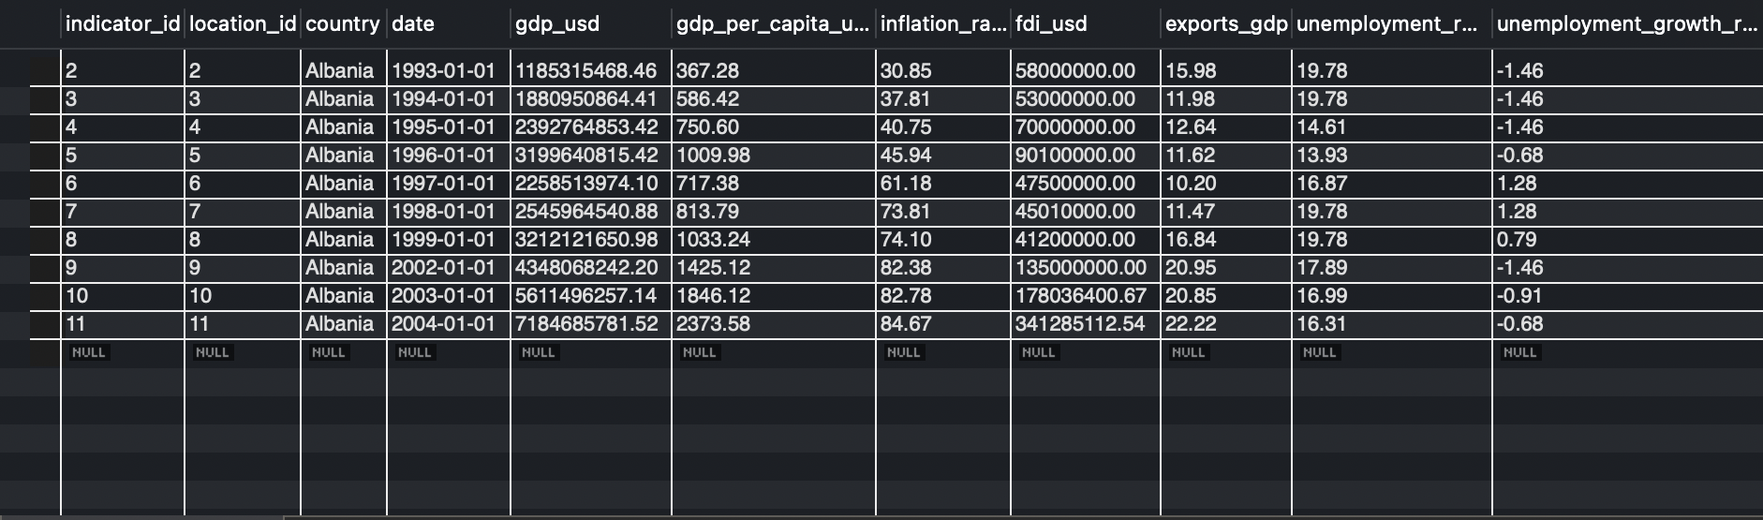

**Explanation:** Retrieves the first 10 rows from the economic_indicators table to get an initial view of the data structure and sample values.

-- Retrieve GDP and GDP Growth Rate for a Specific Country

SELECT country, date, gdp_usd, gdp_growth_rate

FROM economic_indicators

WHERE country = 'Japan'

ORDER BY date;

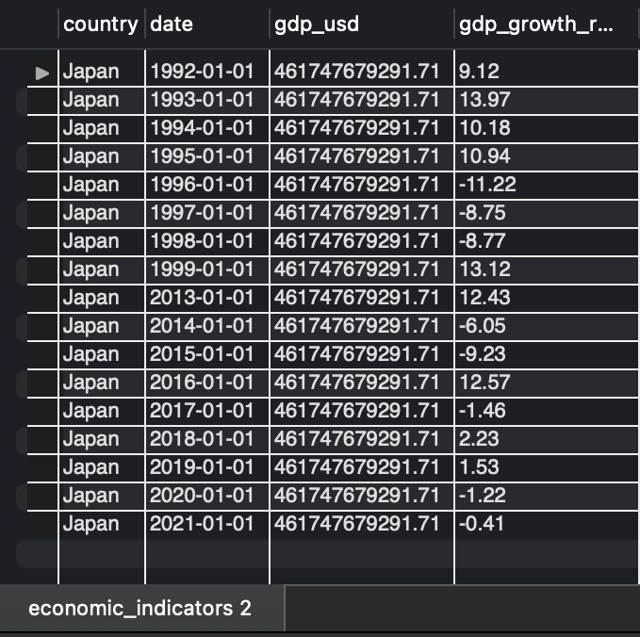

**Explanation:** Fetches the GDP and GDP growth rate over time specifically for Japan, allowing us to observe economic trends for this country.

-- View for GDP and GDP Growth Rate

CREATE VIEW gdp_growth_country AS

SELECT country, date, gdp_usd, gdp_growth_rate

FROM economic_indicators

ORDER BY date;

-- Using VIEW for specific country

SELECT * FROM gdp_growth_country WHERE country = 'Australia';

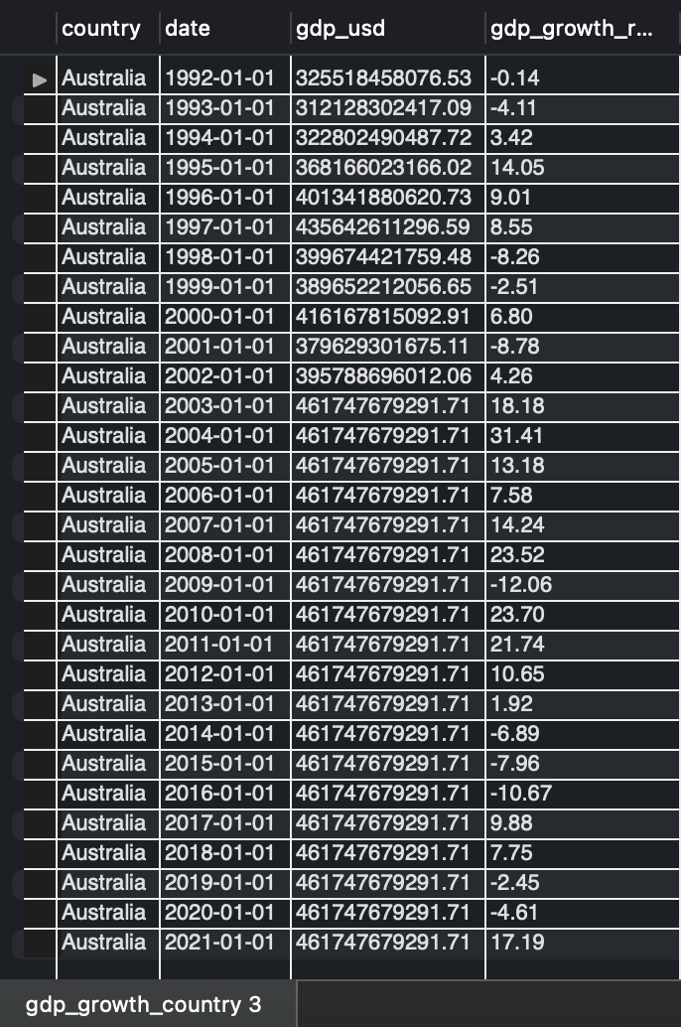

**Explanation:** Creates a view named gdp_growth_country that captures GDP and GDP growth rate data for all countries. You can query this view with filters to focus on specific countries without repeatedly writing the same query.

-- Get Average GDP by Year across all countries

SELECT YEAR(date) AS year, AVG(gdp_usd) AS avg_gdp

FROM economic_indicators

GROUP BY year

ORDER BY year;

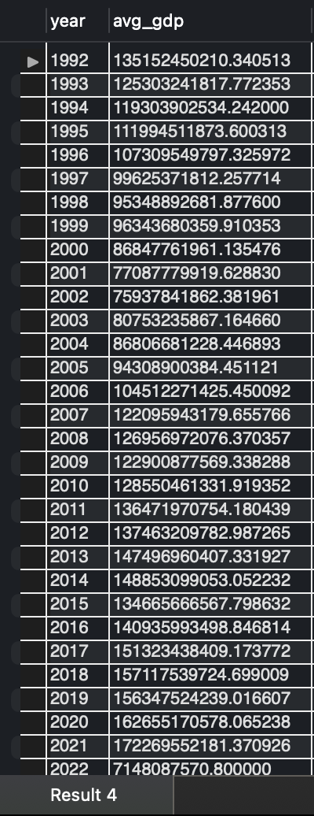

**Explanation:** Calculates the average GDP for each year, providing insights into global economic trends over time.

-- Average GDP Growth Rate by Region

SELECT region, AVG(gdp_growth_rate) AS avg_gdp_growth

FROM economic_indicators

JOIN locations ON economic_indicators.location_id = locations.location_id

GROUP BY region

ORDER BY avg_gdp_growth DESC;

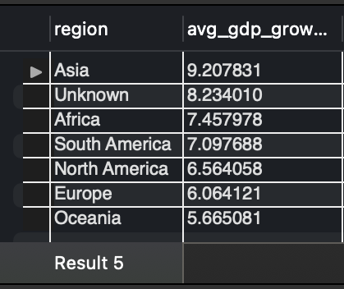

**Explanation:** Calculates the average GDP growth rate by region, allowing comparison of economic growth across different regions.

-- Inflation and FDI Trends for Japan

SELECT date, inflation_rate, fdi_usd

FROM economic_indicators

WHERE country_name = 'Japan'

ORDER BY date;

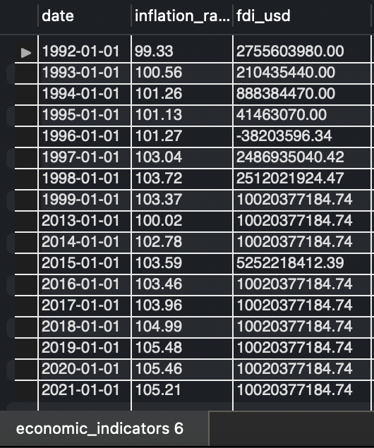

**Explanation:** Retrieves the inflation rate and foreign direct investment (FDI) data for Japan over time, helping to analyze economic stability and international investment trends.

-- View for Inflation and FDI Trends

CREATE VIEW inflation_fdi_country AS

SELECT date, country, inflation_rate, fdi_usd

FROM economic_indicators

ORDER BY date;

-- Using View for inflation

SELECT * FROM inflation_fdi_country WHERE country = 'Germany';

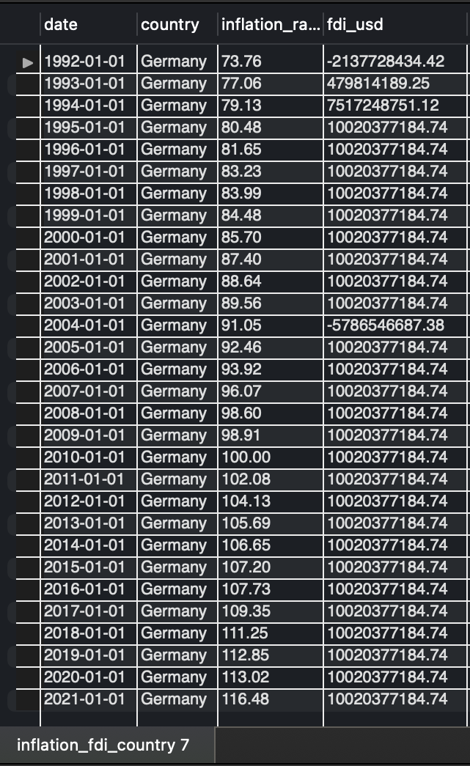

**Explanation:** Creates a view named inflation_fdi_country to streamline retrieval of inflation and FDI data for various countries.

-- Total Exports as % of GDP by Year for Asia

SELECT YEAR(date) AS year, AVG(exports_gdp) AS avg_exports_gdp

FROM economic_indicators

JOIN locations ON economic_indicators.location_id = locations.location_id

WHERE region = 'Asia'

GROUP BY year

ORDER BY year;

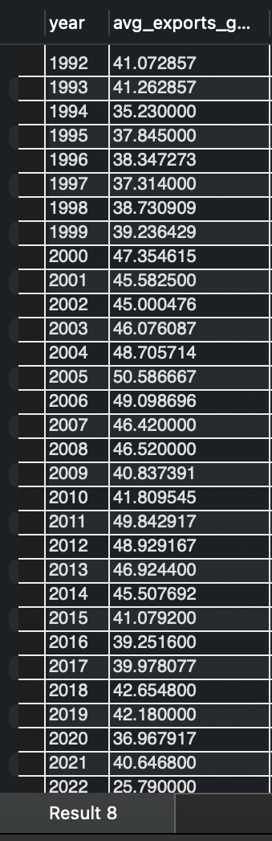

**Explanation:** Computes the average exports as a percentage of GDP for Asia, revealing the region’s dependency on international trade over time.

-- View for Total Exports as % of GDP by Year

CREATE VIEW exports_gdp_region AS

SELECT YEAR(date) AS year, region, AVG(exports_gdp) AS avg_exports_gdp

FROM economic_indicators

JOIN locations ON economic_indicators.location_id = locations.location_id

GROUP BY year, region

ORDER BY year;

-- Using View

SELECT * FROM exports_gdp_region WHERE region = 'Europe';

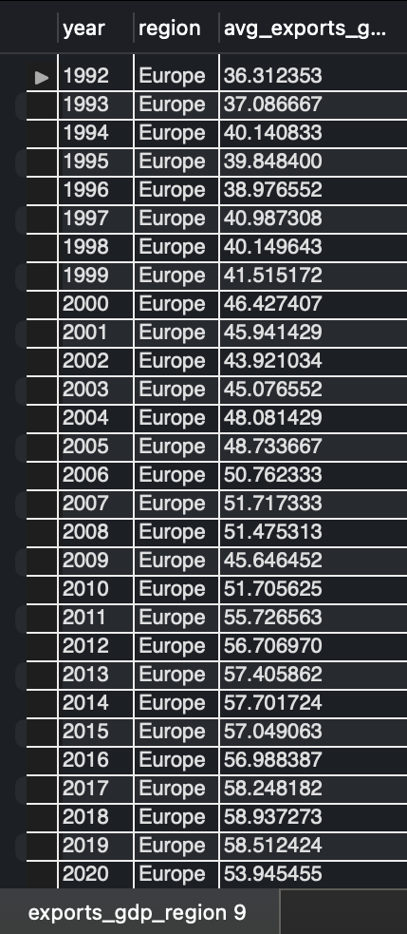

**Explanation:** Creates a view exports_gdp_region to make it easier to track exports as a percentage of GDP by region over time.

-- Stored Procedure for Top N Countries by GDP

DELIMITER //

CREATE PROCEDURE GetTopCountriesByGDP(IN top_n INT)

BEGIN

SELECT country, gdp_usd

FROM economic_indicators

WHERE date = (SELECT MAX(date) FROM economic_indicators)

ORDER BY gdp_usd DESC

LIMIT top_n;

END //

DELIMITER ;

-- Call Stored Procedure for the top 5 countries by GDP

CALL GetTopCountriesByGDP(5);

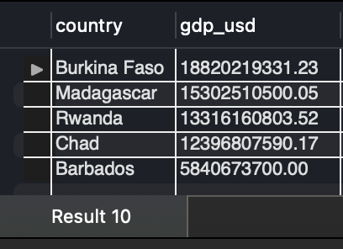

**Explanation:** Retrieves the top N countries by GDP for the most recent year. This helps to identify the largest economies based on GDP.

-- Stored Procedure for Average Inflation by Year for a specific country

DELIMITER //

CREATE PROCEDURE GetAvgInflationByCountry(IN country VARCHAR(50))

BEGIN

SELECT YEAR(date) AS year, AVG(inflation_rate) AS avg_inflation

FROM economic_indicators

WHERE country = country

GROUP BY year

ORDER BY year;

END //

DELIMITER ;

-- Calling stored procedure

CALL GetAvgInflationByCountry('Germany');

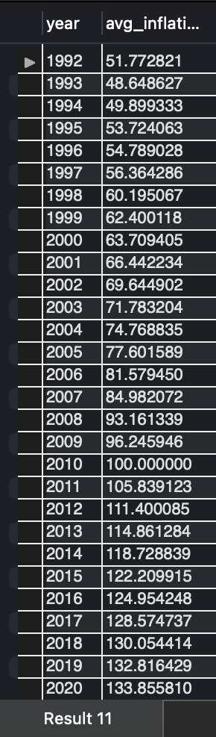

**Explanation:** Calculates the average inflation rate by year for a specified country, helping to analyze inflation trends over time.

-- Function 1: to Calculate GDP per Capita Growth Rate

DELIMITER //

CREATE FUNCTION GetGDPPerCapitaGrowthRate(country VARCHAR(50),year_val INT)

RETURNS DECIMAL(5,2)

DETERMINISTIC

BEGIN

DECLARE gdp_curr DECIMAL(15,2);

DECLARE gdp_prev DECIMAL(15,2);

DECLARE growth_rate DECIMAL(5,2);

-- Get GDP per capita for the specified yea

SELECT gdp_per_capita_usd INTO gdp_curr

FROM economic_indicators

WHERE country = country AND YEAR(date) = year_val

LIMIT 1;

-- Get GDP per capita for the previous year

SELECT gdp_per_capita_usd INTO gdp_prev

FROM economic_indicators

WHERE country = country AND YEAR(date) = year_val - 1

LIMIT 1;

-- Calculate growth rate

SET growth_rate = ((gdp_curr - gdp_prev) / gdp_prev) * 100;

RETURN growth_rate;

END //

DELIMITER ;

-- Use this function

SELECT GetGDPPerCapitaGrowthRate('Australia', 2020);

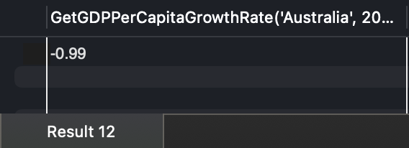

**Explanation:** Calculates the GDP per capita growth rate for a specific country and year, useful for tracking changes in average wealth or productivity.

-- Function 2: to get average inflation rate for certain country

DELIMITER //

CREATE FUNCTION GetAvgInflation(country VARCHAR(50))

RETURNS DECIMAL(5,2)

DETERMINISTIC

BEGIN

DECLARE avg_inflation DECIMAL(5,2);

-- Calculate average inflation

SELECT AVG(inflation_rate) INTO avg_inflation

FROM economic_indicators

WHERE country = country;

RETURN avg_inflation;

END //

DELIMITER ;

-- Use this function

SELECT GetAvgInflation('Japan');

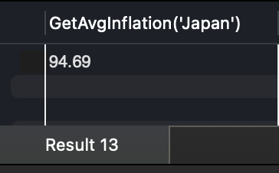

**Explanation:** Computes the average inflation rate for a specified country, helpful for understanding economic stability.

-- Function 3: to calculate year-over-year GDP growth rate

DELIMITER //

CREATE FUNCTION GetYoYGDPGrowth(country VARCHAR(50),year_val INT)

RETURNS DECIMAL(5,2)

DETERMINISTIC

BEGIN

DECLARE gdp_curr DECIMAL(15,2);

DECLARE gdp_prev DECIMAL(15,2);

DECLARE growth_rate DECIMAL(5,2);

-- Get GDP for the specified year

SELECT gdp_usd INTO gdp_curr

FROM economic_indicators

WHERE country = country AND YEAR(date) = year_val

LIMIT 1;

-- Get GDP for the previous year

SELECT gdp_usd INTO gdp_prev

FROM economic_indicators

WHERE country = country AND YEAR(date) = year_val - 1

LIMIT 1;

-- CALCULATE growth rate

SET growth_rate = ((gdp_curr - gdp_prev) / gdp_prev) * 100;

RETURN growth_rate;

END //

DELIMITER ;

-- Use this function

SELECT GetYoYGDPGrowth('Canada',2020);

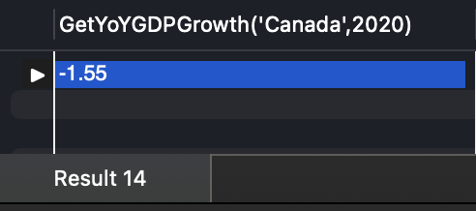

**Explanation:** Calculates the year-over-year GDP growth rate for a specific country, indicating economic growth trends.